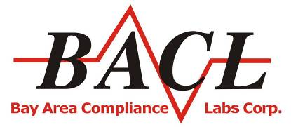
Bay Area Compliance Laboratory Corp.
www.baclcorp.com.cn

Subject: Invitation for BACL Customer Service Survey Visit

Dear Customer ,
How are you,
Many thanks for your support and trust to BACL. In order to improve our service quality and provide excellent services for our customers continue, BACL top management and technical team sincerely invite you attend BACL customer service survey visit. Out top management team will visit your company to listen your comments and any advise, and reply your questions on-site.
Any problems in the past, any suggestions for our future cooperation, any new service request and so on, please feel free to feedback to us. We will discuss with you. Your any comments and good suggestions will be helpful for us, we will also do our best to improve our services for you!
Look forward the meeting with you soon!

Thank you very much!
Yours sincerely,
Bay Area Compliance Labs Corp.
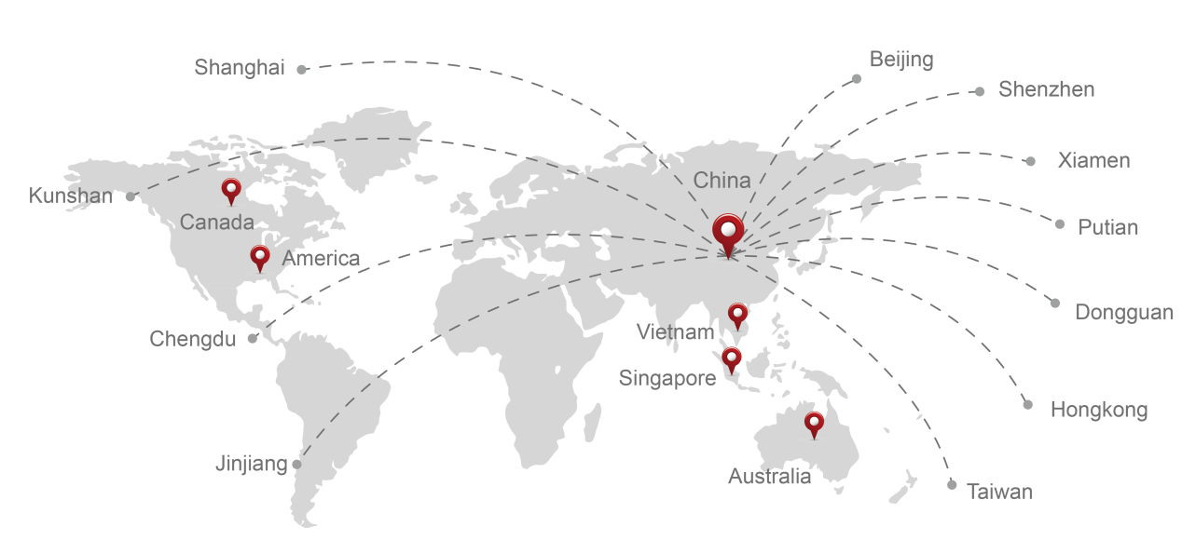

Best Life, Best Service！
Tel: +86 755 33320018 www.baclcorp.com.cn

